 | AIR UNIVERSITY  Multan Campus
 | Department of Computer Science and Engineering
 | DLD Project Design I

Project title: LED Traffic Light
Class: BSCS-F21-Sec A | Department: BS(CS)
Project Participants:
M.Hassaan Nizaal (213060)
Ali Shaan (213033)
Mahir Cheema (213191)
Design I:
Components:
- +9v to +12v supply voltage
- 555 Timer IC
- 1KΩ, 10KΩ, 220Ω resistors (3 pieces),
- 10µF and 100µF capacitors
- RED LED (4 pieces), BLUE LED (4 pieces) and YELLOW LED (4 pieces)
- CD4017 Decade Counter IC
- IN4007 diodes (8 pieces)

Real Time - Diagram:

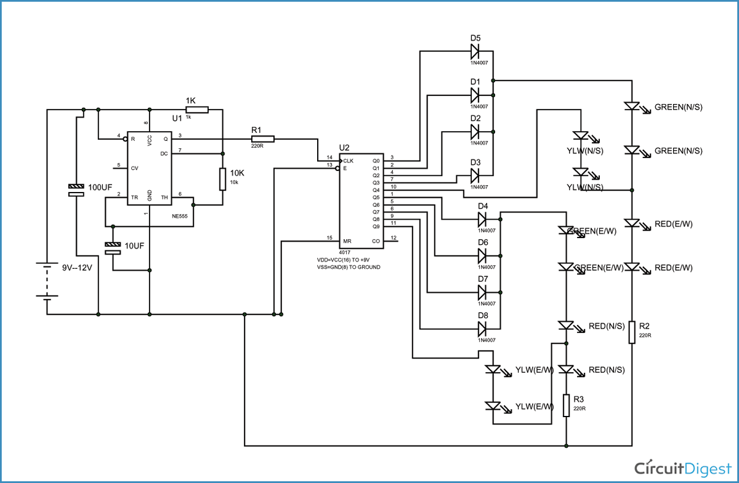
Simplified Block Diagram:

